1. Hazelcast has ability to provide aggregated information about your data.
2. 
3. If you’re developing a bookstore app, one thing you will store is each transaction that has taken place.
   1. On dashboard, you will want to show the total income during a date range.
   2. What we need to do is go & look up all the transactions during that date range.   
      Then we need to sum up all the amounts in those transactions and return that value.
   3. Diagram

      Description automatically generated
   4. A picture containing diagram

      Description automatically generated
4. Let’s see how to do that in Code.
   1. First create a Transaction class in shared module.
   2. 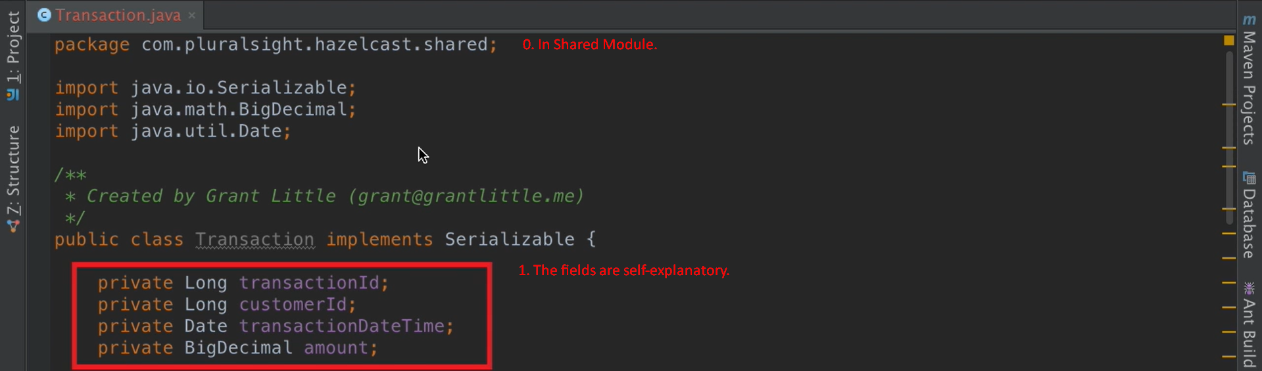
   3. Text

      Description automatically generated
      1. The above class is in Shared Module.
      2. This class is responsible for filtering the transactions based on date range & extracting the amounts from the Transaction.java Objects stored in TransactionsMap (IMap.java).
      3. The class extends **com.hazelcast.mapreduce.aggregation.Supplier<Key, Input, Output>**
   4. Text

      Description automatically generated
      1. ReportingService.java class in Client Module.
      2. The getIncome(Date start, Date end) is important method for aggregation execution.  
         Start and end dates represent the date range for which we want to calculate total income.
5. Let’s write a Unit test to prove it works.
   1. We’re inside **ReportingServiceTest.java  
      The following code is present in 3-hazelcast-getting-started-m3-exercise-files project (Use only after directory under this project).**Text

      Description automatically generated with low confidenceText

      Description automatically generated  
      We’re searching for last 5 days transactions and each transaction is for 1$ so total must be 5$.  
      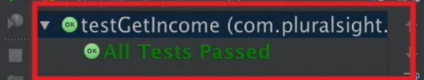
6. Graphical user interface, text, email

   Description automatically generated
7. A picture containing diagram

   Description automatically generated
8. Graphical user interface, text, application, email

   Description automatically generated